FS for Delivery Point Allocation
Name: Adjustment of Delivery Allocated Quantity (Post Ticketing)
Input: Contract ID (single); Gas Day (Multiple)
Processing:
- Pass the contract ID & Gas Day in DOCNR & IDATE field of OIJNOMI table with SITYP= ZD, DOCIND= G, DELIND NE X. Get the location (LOCID), customer (PARTNR) and other details.
- Get the GA_ALLOCATED_QTY by passing the NOMTK obtained from above in OIJNOMI table with SITYP = ZO and DOCIND= K.
- Check presence of ticket for each line item, else pass IDATE & PARTNR to FM YRGR_032_GMS_CT_FM.
- Open the next screen with the details below:
Gas Day | Nomination Key | Contract ID | Business Location | Customer | Delivery Allocation Qty (SM3) | Ticket Status
IDATE of ZD/G | NOMTK of ZD/G | DOCNR of ZD/G | LOCID of ZD/G | PARTNR of ZD/G | GA_ALLOCATED QTY of ZO/K | LV_STATUS of FM
- If FM returns LV_STATUS is ‘COMPLETE’, then make the column ‘Delivery Allocation Qty (SM3)’ as editable. Else, the same shall be un-editable.
- Give a ‘SAVE’ option so that the changed data gets updated in GA_ALLOCATED_QTY of OIJNOMI table for the respective NOMTK/ NOMIT (corresponding to SITYP = ZO and DOCIND= K).
- Calculate daily imbalance again and update the concerned fields in OIJNOMI (refer YRXU006_N for imbalance calculation and concerned fields).
Loop at line 3271 & 3988: Imbalance Calculation
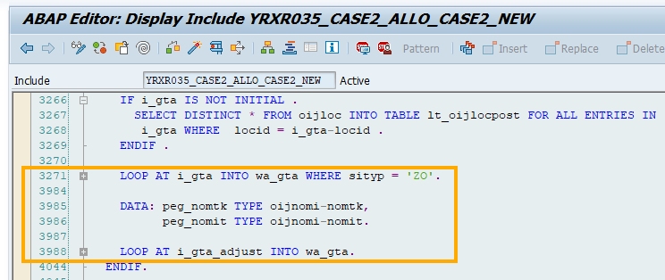

- Add a note in Header ‘Delivery Allocation can only be changed if the ticket is completely posted for the entire GAIL Location or NON-GAIL Customers.’
Validations:
- Pass the Contract ID in VBAK and check AUART. If AUART = ‘ZGT1’ allow further processing, else give error “The contract is not GTA contract’.

